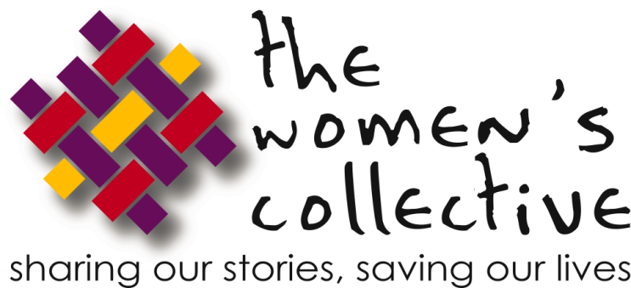

Volunteer Application

Contact Information
Name
Street Address
City, State, ZIP Code
Home Phone
Cell Phone
E-Mail Address

Availability
During which hours are you available for volunteer assignments?
___ Weekday mornings 9-12
___ Weekday afternoons 1-5
___ Weekends
___ Evening
___ Other

How many hours a week would you like to volunteer? ________________

Interests
How did you hear about The Women’s Collective?

____________________________________________________________

Tell us in which areas you are interested in volunteering:
___ Prevention & outreach to the DC community
___ Care & support for women living with HIV//AIDS
___ General office work
___ Fundraising/ Resource mobilization
___ Grants
___ Newsletter production
___ Other

Previous Volunteer Experience
Summarize your previous volunteer experience.

Special Skills or Qualifications
Summarize special skills and qualifications you have acquired from employment, previous volunteer work, or through other activities, including hobbies or sports.

Transportation

Do you have your own means of transportation? | Yes | No
Do you have a valid driver’s license? | Yes | No
Are you willing to drive? | Yes | No

Person to Notify in Case of Emergency
Name
Street Address
City, State, ZIP Code
Cell Phone
Work Phone
E-Mail Address

Agreement and Signature
By submitting this application, I affirm that the facts set forth in it are true and complete. I understand that if I am accepted as a volunteer, any false statements, omissions, or other misrepresentations made by me on this application may result in my immediate dismissal.
Name (printed)
Signature
Date

Our Policy
It is the policy of The Women’s Collective organization to provide equal opportunities without regard to race, color, religion, national origin, gender, sexual preference, age, or disability.

Submit your completed form and resume via email (info@womenscollective.org) or fax (202.483.7330). Thank you for completing this application form and for your interest in volunteering with us.

1818 New York Ave NW, Suite 229
Washington, DC 20002
p: 202.483.7003 • f: 202.483.7330
womenscollective.org

